Geometry Project
Grades 9-12
Summer 2017 – MATH6500
Tom Demars, Amanda Procopio,
& Meghan Brautigam

Table of Contents
Page(s)
Title Page 1
Table of Contents 2
Executive Summary 3
Classifying Polygons/Polygon Capture Game (1 day) 4-8
Classifying Triangles Activity (1 day) 9
Proving Right, Acute, and Obtuse Triangles (2 days) 10
Coordinate Geometry 11,12
Polygons and Triangles Pre/Post Test 13
Interior Angles of Polygons Lesson/Activity (1 day) 14,15
Polygon Properties Lesson 16
Polygon Properties Activity/Chart (2 days) 17
Polygon Properties Pretest 18
Polygon Properties Posttest 19
Angle Pairs Lesson 20
Angle Pairs Activities (2 days) 21-23
Angle Pairs Pretest 24
Angle Pairs Posttest 25
Angles and Segments in Circles Lesson (6 days) 26,27
Angles and Segments in Circles Activity Sheets 28-32
Angles and Segments in Circles Pretest 33
Angles and Segments Posttest 34

Executive Summary
The first four days of this project on polygons and triangles is meant to be an introduction for students on some basic characteristics and rules of polygons and triangles. Students have studied polygons and triangles in previous years, but this unit is meant to provide students with different rules of triangles and polygons through discovery methods. The students will start by discovering the different characteristics of polygons and then they will focus specifically on triangles. They will then spend the next few days discovering different aspects of triangles such as naming them by sides and angles and the Pythagorean Theorem. Students will look at how triangles can be moved to the coordinate plane and use what they have discovered in the previous lessons to classify triangles.
Over the next three days of activities, students will return their focus to polygons and discover how triangles can help them find the interior angle sum of any polygon. This part of the project will also have students doing some drawings of some polygons and measuring angles to help them discover rules for interior and exterior angles in polygons.
Other characteristics of polygons will also be discussed and explored such as symmetry, central angles, vertex angles and diagonals.
This first seven days of this project could be taught all at once, or pieces and activities from it can be used to introduce or add to other units of geometry where they fit.
The next activities focus on angle pairs and terminology. They will be solving puzzle type problems and making their own puzzles to share.
The last few days of activities start with circles. Students will be discovering the relationships between central angles, arc measure, inscribed angles and angles made by secants and chords. They will also be doing activities to discover the relationship between segment lengths (chords, secants and tangents) in and around a circle.
All of the lessons are designed to be done as small group activities, giving students the opportunity to develop understanding in a more meaningful way.

Day 1: Classifying Polygons

Introduction: Students will take a pre-test the day before starting this unit. The students will take the same post-test when they are done with this unit.

MN State Standards:
- 9.3.3.7 Use properties of polygons – including quadrilaterals and regular polygons – to define them, classify them, solve problems, and logically justify results

Materials:
- Polygon Capture Rules
- Polygon Capture Game Cards – Cut out
- Polygon Capture Game Polygons – Cut out

Launch:
- Hand out the Polygon Capture Rules to each student. Briefly go over them so students understand the basic rules. Then play an example round with the students – teacher vs. student.
Explore:
- Break the students up into groups of four.
- Have them play Polygon Capture against one other person in their group. Once they finish their first game, students should play against a different person in their group of four.
- Students should play this game multiple times to get a hang of how it works and to start building a strategy for how they play.
Share:
- Once students are done playing the game, have them discuss with their groups any strategy they used as they played their different games. Did they change how they played the second game? Did they change every time they played? Did they find a strategy that seemed to work well? Did they notice a strategy that did not work well?
- After students discuss with their groups of four, have the whole class discuss their strategies.
- Next, have students discuss properties they notice about ALL the shapes in the game. Since these are all polygons, students should be able to list properties of polygons such as:
  - Straight edges
  - Do not all have to have the same size sides
  - Angles can vary from acute, right, and obtuse
  - All shapes are closed
  - Shapes can have any number of sides
  - Shapes can be concave or convex
  - All shapes are two-dimensional
Summary:
- By the end of the discussion, make sure that students get all of the properties listed above so that they know the properties of polygons and have them written down. If the students are missing any of the properties, ask them guiding questions to help them come up with these properties.
- We will be focusing specifically on triangles for the next few days.

Source: http://illuminations.nctm.org/lesson.aspx?id=665
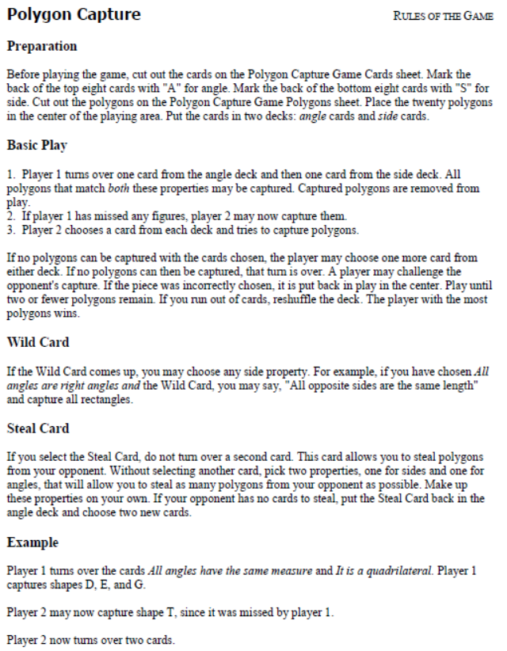

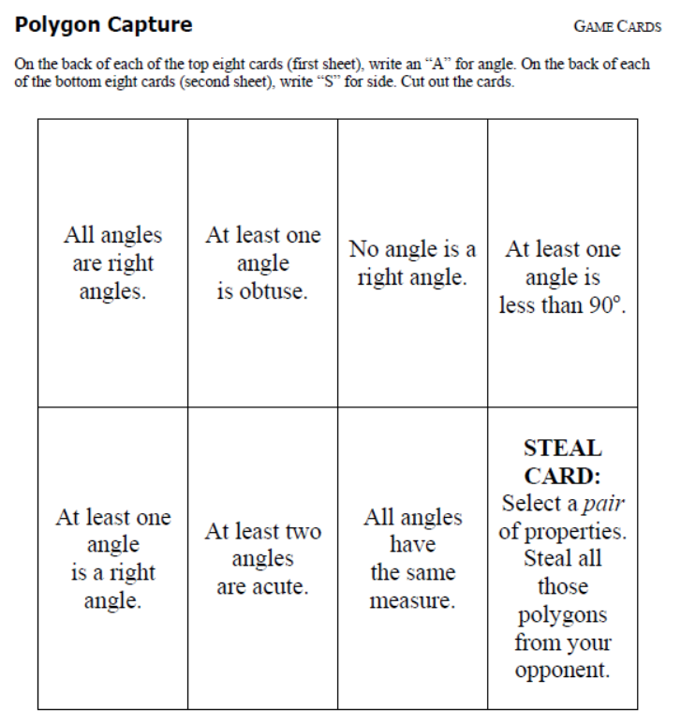

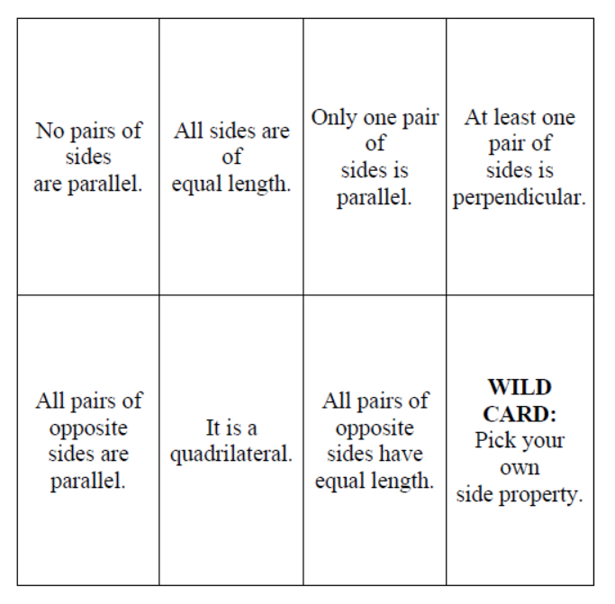

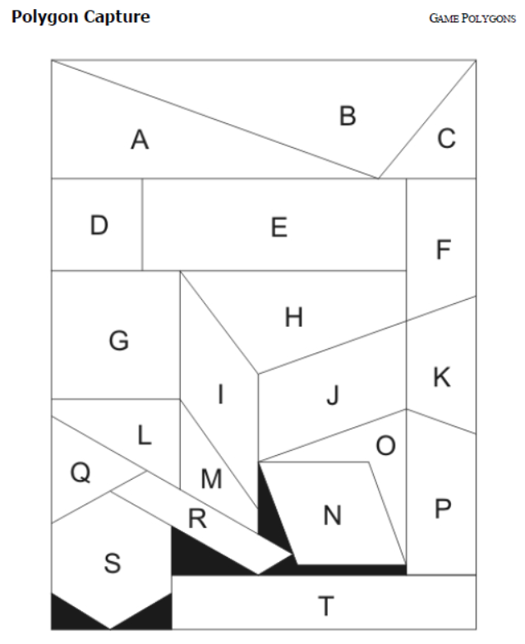

Day 2: Classifying Triangles

MN State Standards:
- 9.3.3.3 Know and apply properties of equilateral, isosceles, and scalene triangles to solve problems and logically justify results

Materials:
- Large sheet of blank paper – 1 per group
- 6 different coloring utensils per group
- Rulers
- Protractors

Launch:
- We are going to focus on triangles for the next few days.
- Ask the questions:
  - How can you classify triangles according to their angle? (acute, right, obtuse)
  - How can you classify triangles according to their sides? (equilateral, isosceles, scalene)
  - Discuss what these terms mean in case any students have not heard them before.
Explore:
- In front of the class, draw line segment AB. Then have a student come up and plot a random point C. Ask students what they know about the triangle now formed by these three points. Is the triangle acute? Right? Obtuse? Equilateral? Isosceles? Scalene? How do you know?
- After a short discussion, students will get into a group of four with a large sheet of blank paper and 6 different coloring utensils.
- Students will draw a line segment AB on their sheet. Then they will find all points C such that triangle ABC is:
  - Acute – denoted with red color
  - Right – denoted with orange color
  - Obtuse – denoted with yellow color
  - Equilateral – denoted with green color
  - Isosceles – denoted with blue color
  - Scalene – denoted with purple color
- Students may use a protractor and ruler to check their points to make sure their sides and angles satisfy the different classifications.
- When students finish, have them hang their sheet of paper on the wall somewhere around the room.
Share:
- Have different groups explain how they knew certain C points would lead to certain triangles. Most groups should have similar looking triangles on their pages.
- Students should make note that for some types of triangles (right for example) there are only a certain number of triangles that can be formed from a pre-existing line segment, whereas for others (isosceles for example) there are numerous possibilities.
Summary:
- By the end of the day, students should be comfortable with identifying the different types of triangles based off of side length and angle measures. Seeing the different examples around the room should help them review the different possibilities of each type of triangle.

Day 3: Proving Acute, Obtuse, and Right Triangles

MN State Standards:
- 9.3.3.4 Apply the Pythagorean Theorem and its converse to solve problems and logically justify results

Materials:
- Blank paper
- Ruler
- Calculator

Launch:
- In the previous lesson, students learned about acute, obtuse, and right triangles and could use a ruler and protractor to classify them.
- In this lesson students will be able to use algebra to prove whether a triangle is acute, obtuse or right.
- Break students up into groups of three. Each person needs a blank sheet of paper and a ruler.
- One person in the group will draw an acute triangle, one person will draw a right triangle, and one person will draw an obtuse triangle. Using what they learned the previous day, students should quickly review with their group how they know the triangle they drew is correct.
Explore:
- Once the appropriate triangles are drawn, each student must measure and label the sides of their triangle. Then, they will find the measure of all the sides squared.
  - For example, students will find the side measures a, b, and c. Then they will calculate a², b², and c².
- Next, students will record their answers on the board under the appropriate heading: Acute, Obtuse, or Right. This will provide data for the side lengths and squared side lengths for all of the acute, obtuse, and right triangles created in the class.
- Once all of the data is posted, students will work in their groups to try and come up with any patterns they see between the values they found.
Share:
- Students will share their answers with the class. Each group should mention at least one pattern or fact their group discovered.
- After a group shares, it is important to check their pattern or fact with the measurements posted on the board to make sure it’s valid. It is also important to ask follow up questions on why a certain pattern may exist.
Summary:
- By the end of the lesson, and this may need to result in some teacher direction if it is not discovered, students should know the following rules:
  - In order for three sides to form a triangle, the sum of any two sides must be greater than the third side.
  - Assuming sides a, b, and c (with c being the longest side):
    - If a² + b² = c², then the triangle is a right triangle
    - If a² + b² < c², then the triangle is obtuse
    - If a² + b² > c², then the triangle is acute
- We will be looking at practice examples the following day.

Day 4: Coordinate Geometry

MN State Standards:
- 9.3.3.3 Know and apply properties of equilateral, isosceles, and scalene triangles to solve problems and logically justify results
- 9.3.3.4 Apply the Pythagorean Theorem and its converse to solve problems and logically justify results
- 9.3.4.4 Use coordinate geometry to represent and analyze line segments and polygons, including determining lengths, midpoints, and slopes of line segments

Materials:
- Coordinate Geometry worksheet

Launch:
- Students will begin by practicing the rules of triangles they learned the previous day. They will be given four different sets of numbers. They must work with their partner to determine if the three sides form a triangle, and if they do they must classify it as acute, right, or obtuse.
- Examples:
  - 4, 8, 5 (obtuse); 9, 12, 15 (right); 5.6, 10.1, 4.2 (not a triangle); 11.4, 6.8, 12 (acute)
  - It is important that students know that c must be the longest side of the triangle and that they must check that the three sides form a triangle first.
Explore:
- Hand out the Coordinate Geometry sheet to the students. Have the students look at the first example and ask them what type of triangle it is. Do not tell them if they are right. They must be able to tell you what kind of triangle it is without using any measuring tools such as a ruler or protractor.
- After these instructions are given, let students work in their groups to come up with an answer.
Share:
- After all groups have had time to work out an answer, have them write their answer on the board with some sort of work or explanation as to how they got their answer.
- Students will take turns sharing in their groups the strategies they used to figure out what kind of triangle it was.
  - No “correct” method should be given by the teacher. Students should decide for themselves which method they would like to. The teacher should only intervene if students are using a ruler or protractor, or if what they are doing in their algebra is incorrect.
- Students will then work in their groups to finish the rest of the Coordinate Geometry worksheet. They should continue to share strategies they use throughout to come up with their answers.
Summary:
- The main objective of this lesson is to get students to use the rules they learned in the previous lesson to classify triangles on a coordinate plane. In order to do this, they must first use the Pythagorean Theorem to find the side lengths, and then calculate a², b², and c² to figure out what kind of triangle it is.
- The purpose of this lesson is to get them to practice these skills in a different way than just assigning homework problems. This group work should open new viewpoints and ideas for students to try.
Coordinate Geometry
Determine if the following triangles are acute, obtuse, or right. Be sure to show your work for each problem to justify your answer.

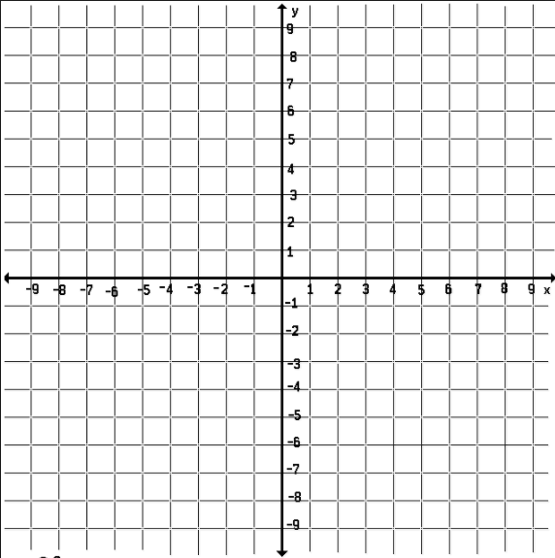

Polygon and Triangle Pre/Post Test

- Name three properties of polygons:

- How would you name this triangle based off of its sides and angle measures?

Sides: ____________________ angles: ____________________

- Given three line segments, determine if they form a triangle. If they do, state what kind of triangle they form.

  - 3.1, 11.2, 5.8 b. 12, 8, 6

Do they form a triangle? YES or NO Do they form a triangle? YES or NO

If yes, what kind of triangle? __________ If yes, what kind of triangle? _________

- Determine whether the triangle is acute, obtuse, or right. You must show all of your work to justify your answer.
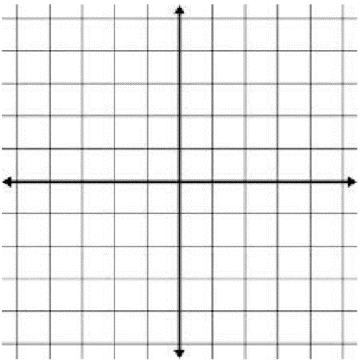

Type of triangle: _________________

Interior Angle Sum of Polygons

MN State Standards:
- 9.3.3.3 Know and apply properties of equilateral, isosceles, and scalene triangles to solve problems and logically justify results
- 9.3.3.7 Use properties of polygons – including quadrilaterals and regular polygons – to define them, classify them, solve problems, and logically justify results

Materials:
- Protractor
- Compass
- Blank sheets of paper

Launch:
- Now that we have looked at triangles, we are going to learn how they help us find the angle sum of a polygon.
- Review properties of a polygon as a class. Let them know that we give specific names to polygons based on their number of sides. This isn’t crucial to the lesson, but it may help some of their discussions. These names based on sides are:
  - 3: triangle, 4: quadrilateral, 5: pentagon, 6: hexagon, 7: heptagon, 8: octagon, 9: nonagon, 10: decagon, 11: hendecagon, 12: dodecagon,…, n: n-gon
  - Have these listed so that students can refer back to them.
Explore:
- Break the students up into groups of six. Each group member should have a protractor and a blank sheet of paper. Have one member from each group draw a triangle, one draw a quadrilateral, one draw a pentagon, one draw a hexagon, one draw a heptagon, and one draw a hexagon.
- Each person is going to measure each angle in their figure and find the interior angle sum.
- Once each group has done this, students should write their answers on the board. Each shape with the same number of sides should have the same sum, so make sure groups double-check their measurements if something isn’t right.
- Have students work in their groups to see if they can come up with a rule to determine how to find the interior angle sum. At this point, some groups may relate it to side length and others may not.
Share:
- Once students have an idea about the relationship between side lengths and interior angle sum, have each group share their thoughts.
- Make sure each group gets a chance to speak and that they are justifying their thoughts based off of the information we found as a class. As more groups speak, students should realize that it has something to do with how many sides a polygon has.
- If no groups come up with a formula, tell them it has something to do with triangles and let them think in their groups again. Hopefully this will guide them in the right direction.
- Have students write the formula or idea they came up with on the board. If any group came up with the correct formula, have them explain their reasoning to the class.
Summary:
- By the end of class, students should know why the formula for the interior angle sum of a polygon is: Sum=(n – 2) x 180, where n is the number of sides.
- If no groups can thoroughly explain why this is true, show students how each polygon can be broken into non-overlapping triangles. If time allows, this discovery can be introduced step-by-step with the students so that they help come up with the formula as a class instead of the teacher just giving them the formula.
- Students should have measured the interior angle sum of any triangle to be 180, so this is where the 180 comes from in the formula. The n – 2 piece comes from the number of triangles that can be found in a polygon. If there are n sides to a polygon, then there are n – 2 triangles that can be created.
- For example:
  - A quadrilateral (n = 4) can be divided into two non-overlapping triangles. Thus, (4 – 2) x 180 = 360, which is what students should have found for their interior angle sum of a quadrilateral at the beginning of class.

180ᵒ
180ᵒ

  - A pentagon (n =5) can be divided into three non-overlapping triangles. Thus, (5 – 2) x 180 = 540, which is what students should have found for their interior angle sum of a pentagon at the beginning of class.

180ᵒ

180ᵒ

180ᵒ

  - This break down and pattern can be shown for all polygons.

Conclusion: After the first four days, students will take a post-test that is identical to the pre-test they took at the beginning of the unit.

**It should be noted that this unit may go longer than 4 days. If students are to truly get out of it what they should with the discovery, discussion, and sharing aspects, then I anticipate some of these lessons dragging into the following day.

Lesson: Polygon Properties(2 days)
Objective: Students will understand terms associated with polygons including: central angle, interior and exterior angle, symmetry and diagonals. Students will also develop an understanding of properties associated with these parts of polygons.
Standards: 9.3.3.7 Use properties of polygons – including quadrilaterals and regular polygons – to define them, classify them, solve problems, and logically justify results.

Launch: This lesson should take place after the previous lesson on interior angles in polygons. For this lesson we will focus on regular polygons. We will need to define (or review) terms including exterior angle, central angle, diagonal and symmetry. Now that the sum of interior angles have been explored, the instructor will pose questions such as:
What is the measure of each angle in a decagon, or 100-gon?
What is the sum of the exterior angles in a decagon, or a 100-gon?
How many diagonals in a pentagon?
Explore: Students will be working in groups of 3-4. Students will work with drawings of regular triangles, quadrilaterals, pentagons, hexagons and octagons. Different polygons should be assigned to each member of the group to divide up the work and so everyone participates. They will measure all exterior angles and record the results on the drawings. Using prior knowledge about triangles and interior angles, along with their measurements for these shapes they will begin to fill in the polygon chart. The chart will also include other properties of polygons for students to complete.They can use their drawings to help them answer and develop an understanding they can apply to all polygons. They will be asked to see if they can identify patterns and determine the results for polygons with more than 8 sides and any polygon (n-gon) and include those answers in their chart.

Share: Each group will be asked to compare their results with another group in the room and resolve any differences. Each of the groups will be asked to share some of their results with the class by filling in one chart located in the room. After the chart is completed, each group will need to compare with their chart and again look for any differences.

Summarize: The instructor will facilitate a class discussion in order to bring everyone to a consensus about the accuracy of the chart. After everyone agrees the chart is correct, the instructor will continue to lead a class discussion about each column in the chart and the mathematical rational behind each pattern by having individuals from each group support their results.

NAME:___________________

POLYGON PROPERTIES

Using drawings of regular polygons including triangle, quadrilateral, pentagon, hexagon, and octagon, fill in the chart.

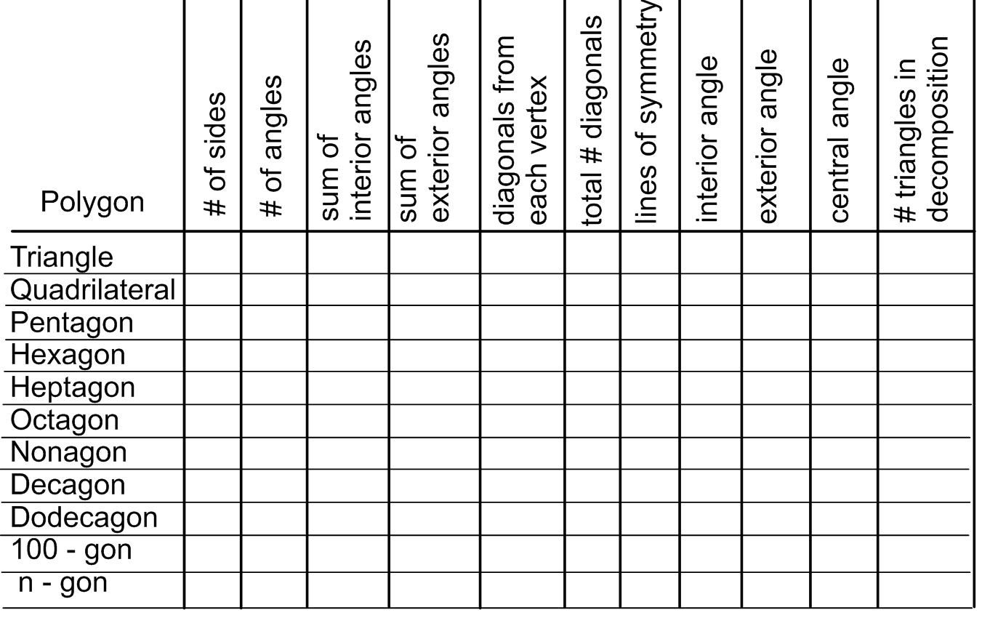

Name:___________________

Polygon Properties Pre-Test

1. What is the sum of the interior angles in each polygon?
a.) hexagon
b.) nonagon
2. What is the sum of the exterior angles in an octagon?

3. How many lines of symmetry does a regular heptagon have?

4. What is the measure of an interior and an exterior angle in each regular polygon?
a.) pentagon

b.) decagon

5. How many diagonals are there from each vertex in each regular polygon?
a.) dodecagon

b.) 20 – gon

6. What is the measure of the central angle in each regular polygon?
a.) 18 – gon

b.) octagon

Name:___________________

Polygon Properties Post-Test
1. What is the sum of the interior angles in each polygon?
a.) pentagon

b.) decagon

2. What is the sum of the exterior angles in a 20-gon?

3. How many lines of symmetry does a regular nonagon have?

4. What is the measure of an interior and an exterior angle in each regular polygon?
a.) hexagon

b.) octagon

5. How many diagonals are there from each vertex in each regular polygon?
a.) 14-gon

b.) heptagon

6. What is the measure of the central angle in each regular polygon?
a.) 20 - gon

b.) dodecagon

Lesson: Angle Pair Practice
(2 days)
Objective: Students will develop an understanding of the terms involving angle pairs associated with and including parallel lines and transversal. The angle pairs include: alternate interior, consecutive (same side) interior, alternate exterior, consecutive (same side) exterior, corresponding, vertical and adjacent.
Standards:
9.3.3.1 Know and apply properties of parallel and perpendicular lines, including properties of angles formed by a transversal, to solve problems and logically justify results.
9.3.3.2 Know and apply properties of angles, including corresponding, exterior, interior, vertical, complementary and supplementary angles, to solve problems and logically justify results.
Launch: This lesson will take place after the students have been introduced to the concepts of terms involving angle pairs associated with and including parallel lines and transversal. The angle pairs include: alternate interior, consecutive (same side) interior, alternate exterior, consecutive (same side) exterior, corresponding, vertical and adjacent.
The students will be given 4 (or more) problems (puzzles) that will require them to use their new understanding of terms.
Explore: Students will be working in groups of 3-4. Each group will be given problems where clues will be given as to where angles will be placed when two parallel lines are crossed by a transversal. Using the clues that will include angle pair terminology, groups will try to place angles in the appropriate location. In some of the problems one angle will be placed as a starting point, and in others no angle will be placed.
On day 2, groups will be making their own problems similar to what they have been working on the first day to share with other groups.
Share: When each group has finished a problem they will be asked to share their results with the class by first identifying an angle with reference to the clue that they used. Groups will take turns identifying the angles and referencing the clue.
On day 2, groups will share their own puzzles with the other groups and a similar sharing process will ensue with the problems being posted on the board and groups taking turns with identifying the angles and referencing the clue that they used.
Summarize: Students will be utilizing the terminology by reading, writing, and applying the terms and will develop a solid understanding of each term.

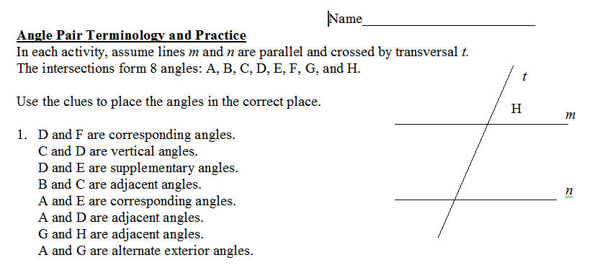

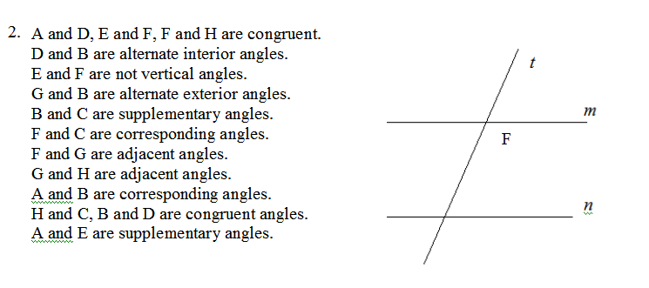

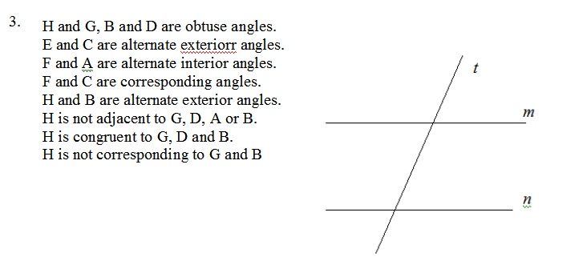

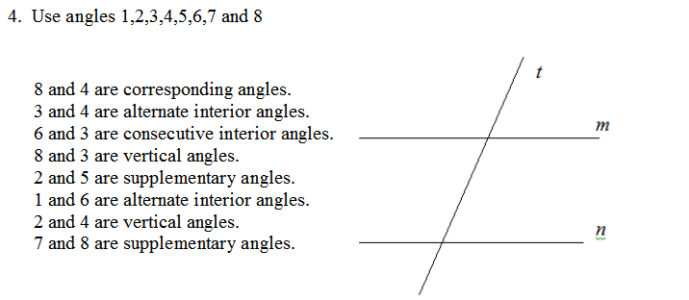

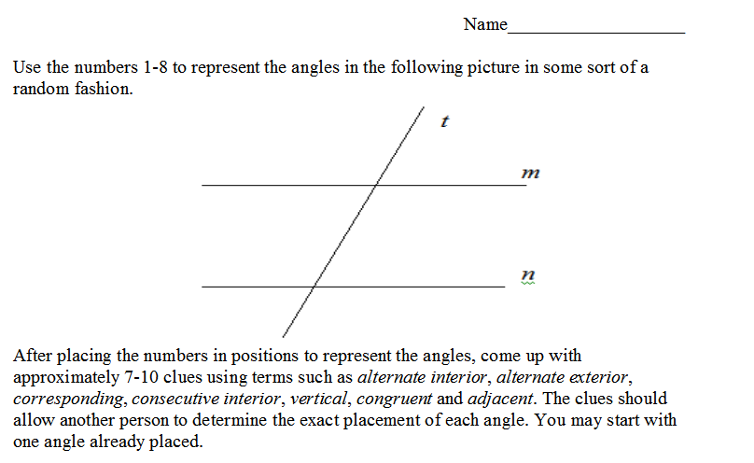
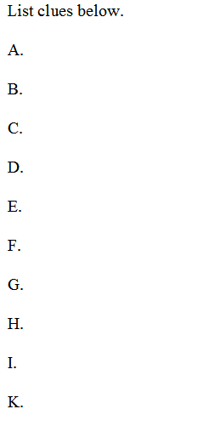

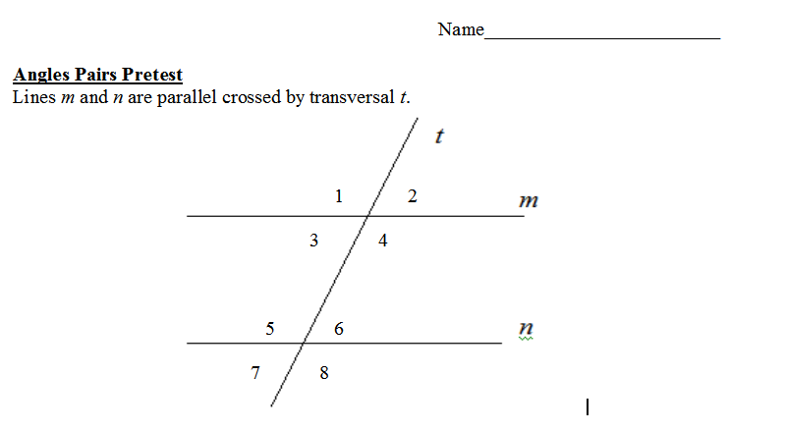
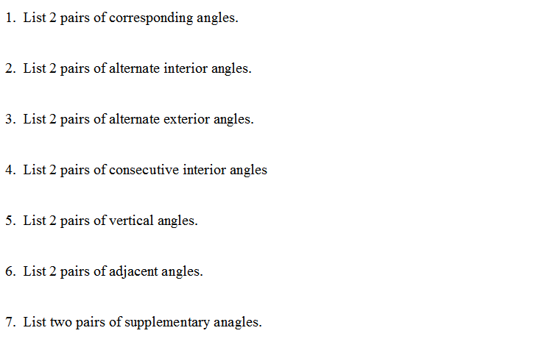

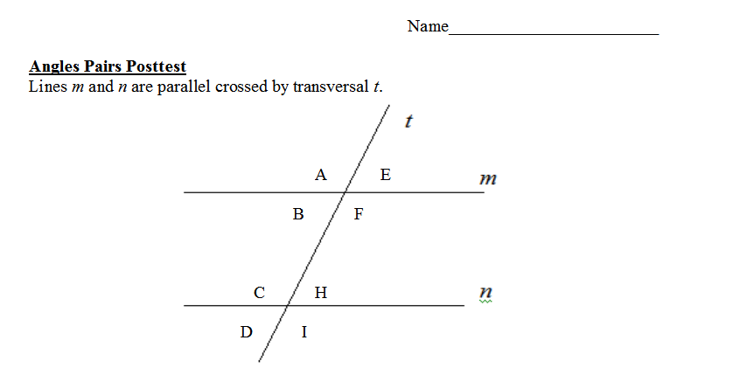

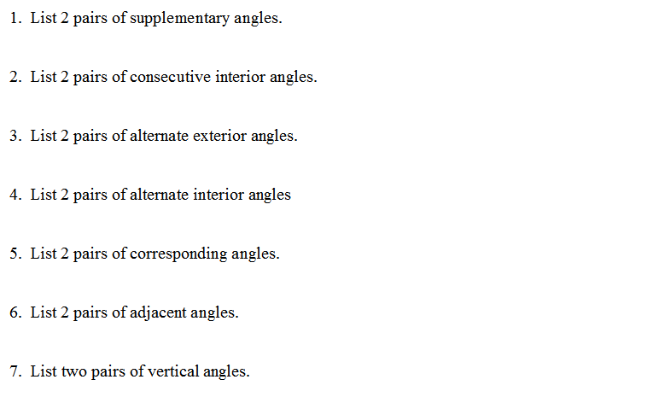

Lessons: Angles/Segment in Circles (6 days)

Objective: Students will “discover” the relationships between angle measures and arc measures in a circle. This includes angles in which the vertex is either on the circle, in the interior of a circle or on the exterior of the circle. Students will also “discover” the relationships involved in chord, secant and tangent lengths in circles.

Standard: 9.3.3.8 Know and apply properties of a circle to solve problems and logically justify results.
Launch: The instructor will review concepts central angle and arc measure and how they are related and introduce the concepts of inscribed angles, angles made by chords inside a circle and angles made by secants or tangents on the exterior of a circle. Students will then be asked to make some initial guesses as to how the angles and arc measures are related.
After angle measures are explored, the relationships involving chord, secant and tangent lengths will be brought up and students will again be asked to make some initial guesses about what those relationships might be.

Explore: There are five different exploration activities that will take five days with a daily summary of results.

Day 1: Explore inscribed angles and their relationship to intercepted arcs.

Day 2: Explore interior angles made by 2 chords and their relationship to intercepted arcs.

Day 3: Explore exterior angles made by either two secants, two tangents, or one tangent and one secant.

Day 4: Explore segment lengths when two chords intersect.

Day 5: Explore segment lengths when secants and/or tangents intersect.

Students will initially get into groups of 2-3. Each person in the group will be responsible for drawing circles, measuring angles and segment lengths, labeling and recording results. The group will then come up with their conjecture as to how the angles are related to arc measure or how segment lengths are related. The instructor may have to give some hints to get groups on the right track.
Share: After the groups have collected their data each day and determined their conjectures they will be asked to post their results in class. A discussion will then take place where students will explain their results and their conjectures.
Summarize: The 5 activities in this lesson will take 5 days. Each activity will conclude with a summary that was hopefully “discovered” by the students. On day 6, and, once the 5 activities are completed each group will be asked to make comprehensive summary by making a small poster that illustrates the concepts learned. The idea is that this poster may include their conjectures, but pictures, diagrams, illustrations and formulas should be the focus here. These posters will be placed in the room and each group will be asked to explain different aspects of their poster. Each group will then vote on the poster they think is the “best” (easily understandable and accurate). The winning group will receive a fabulous prize!

